**Project Design Phase-I**

**Solution Architecture**

|  |  |
| --- | --- |
| Date | 06 May 2023 |
| Team ID | NM2023TMID01136 |
| Project Name | Identifying airline passenger satisfaction using machine learning |

**Solution Architecture:**

Solution architecture is a complex process – with many sub-processes – that bridges the gap between business problems and technology solutions. Its goals are to:

* Find the best tech solution to solve existing business problems.
* Describe the structure, characteristics, behavior, and other aspects of the software to project stakeholders.
* Define features, development phases, and solution requirements.
* Provide specifications according to which the solution is defined, managed, and delivered.

**Example - Solution Architecture Diagram:**

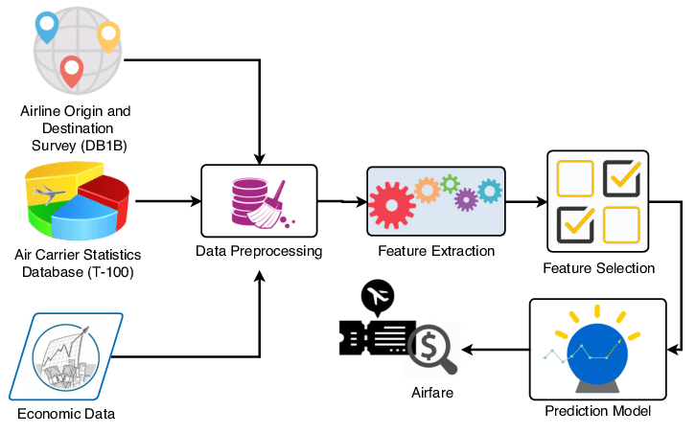

*Figure 1: Architecture and data flow of the airline price prediction sample application*

**Reference:** https://www.google.com/search?q=solution+architecture+diagram+for+airline+passenger+satisfaction+using+ml&rlz=1C1VDKB_enIN1053IN1053&sxsrf=APwXEdfEURO_gEhnz650hnzFyXxX20Togg:1684513403712&source=lnms&tbm=isch&sa=X&ved=2ahUKEwiVurC45YH_AhWY4zgGHXJjCbsQ_AUoAXoECAEQAw&biw=1280&bih=649&dpr=1.5#imgrc=0AMsA6CuGf5EUM

